**Stack or Stagger: NBA Lineup Analysis**

Track: Basketball

ID: 433510

1. **Introduction**

The Los Angeles Lakers were +13.97 (points per 100 possessions) with LeBron James and Anthony Davis on the floor in the 2020 playoffs. However, with both players off the floor, they were a whopping -45.62. Countless other examples illustrate a similar phenomenon: Kobe Bryant and Shaquille O’Neal in 2001 (+15.3 and -9.01), Kawhi Leonard and Kyle Lowry in 2019 (+10.2 and -10.5); even the all-time great 2017 Golden State Warriors fell from +17.36 to -0.77 with Stephen Curry and Kevin Durant on the bench. Simply put, while a team may experience incredible highs while its stars share the floor, the losses during the few minutes they rest together can be catastrophic. As such, an optimization problem arises: how should a coach distribute minutes among the star players in order to maximize the team’s chances of winning? Should they stack their stars, playing them together for long stints, while also risking the consequences of the few minutes where both players sit on the bench? Or would it be more effective to stagger the players, playing them together less often, but ensuring that at least one of the two stars is on the court at all times?

This paper seeks to address this question by evaluating the net ratings for every team's regular season lineups dating back to 2010. Section 2 provides a brief analysis of the benefits of stacking or staggering leaguewide, without accounting for the strengths and weakness of an individual team. Section 3 then provides insights into those team differences, highlighting plausible factors to consider when deciding to stack or stagger stars. Finally, the overall results and future areas of work are discussed in Sections 4 and 5 respectively.

1. **Stack of Stagger Leaguewide**

**2.1. Methodology**

In order to evaluate the benefits of stacking or staggering stars, it was first necessary to formulate a metric measuring the strength of both strategies. This stack or stagger evaluation metric, henceforth denoted α, was calculated by comparing the tradeoff between stacking and staggering on pairwise time chunks. Consider two arbitrary time chunks within a single game, each of the same length, denoted T1 and T2. Consider also a team that has two star players, P1 and P2, each of whom are allowed to play during one of the two time chunks. Given the goal of optimizing the team's overall performance, we must now decide between 4 allocations of the time chunks among the players:

|  |  |  |  |  |  |  |  |  |  |  |
| --- | --- | --- | --- | --- | --- | --- | --- | --- | --- | --- |
| 1. Both players play in T1 | |  |  |  | | --- | --- | --- | |  | T1 | T2 | | P1 |  |  | | P2 |  |  | |
| 1. Both players play in T2 | |  |  |  | | --- | --- | --- | |  | T1 | T2 | | P1 |  |  | | P2 |  |  | |
| 1. P1 plays in T1 and P2 plays in T2 | |  |  |  | | --- | --- | --- | |  | T1 | T2 | | P1 |  |  | | P2 |  |  | |
| 1. P1 plays in T2 and P2 plays in T1 | |  |  |  | | --- | --- | --- | |  | T1 | T2 | | P1 |  |  | | P2 |  |  | |

Because the two time chunks are arbitrary, there is no material difference between allocations 1 and 2, or 3 and 4. As such, there are only two choices:

1. P1 and P2 play together (stacking)
2. P1 and P2 play separately (staggering)

In order to calculate the effectiveness of these two strategies, we must evaluate the performance of the team (per minute) for each of the four following lineup combinations, hereafter denoted L1-L4:

1. P1 off, P2 off
2. P1 on, P2 off
3. P1 off, P2 on
4. P1 on, P2 on

Assuming an equal pace of 100 possessions per 48 minutes for each of the four lineups[1], the net ratings for each of these lineups (points/100 possessions), denoted N1 - N4 respectively, can then be used to calculate α as follows:

|  |  |  |
| --- | --- | --- |
|  | $$α={(N}_{1}+ N_{4}- N_{2}- N_{3})$$ | (1) |

$α$ indicates the net improvement a team would see from replacing 2 games of staggered lineups (48 min each for L2 and L3) with 2 games of stacked lineups (48 min each for L1 and L4). A positive α indicates a team that would stand to improve by stacking its stars, while a negative α indicates the benefits of staggering.

The goal of either stacking or staggering is to maximize the team’s point differential over the course of a game. The team’s overall point differential can be maximized by maximizing S in Equation 2, where M1-M4 indicate the minutes played for lineups L1-L4.

|  |  |  |
| --- | --- | --- |
|  |  | (2) |

However, this equation can simply be maximized by finding the largest Ni and setting the corresponding Mi to 48 minutes, which is an unrealistic distribution of minutes. As such, additional constraints must be placed on the equation in order to ensure that both star players play an appropriate number of minutes. This is achieved by finding the average number of minutes played per game by each player (MP1 and MP2) and enforcing these values as the number of minutes played for both players.

|  |  |  |
| --- | --- | --- |
|  | $$M_{P1}=M_{2}+M_{4}$$ $$M_{P2}=M_{3}+M_{4}$$ | (3) |

Equations 2 and 3 can be combined and simplified to write S in terms of only a single unknown: M1.

|  |  |  |
| --- | --- | --- |
|  |  | (4) |

However, once again, when maximized the equation provides unrealistic results. Whenever α > 0, the equation is maximized by the maximum value of M1 and whenever α < 0, the equation is maximized by the minimum value of M1. However, this often results in suggested rotations where some of the four lineups never see the floor, i.e., M1 = 0. As such, it was necessary to add a regularizing term to the equation to push M1 away from extreme low and high values. This regularizing term, λ, was calculated as the estimated density of M1*, as defined in Equation 5, across the entire dataset.

|  |  |  |
| --- | --- | --- |
|  | $$λ=f\left(M_{1}^{*}\right)=f\left(\frac{M_{1}}{Max_Val\left(M_{1}\right)}\right)= f\left(\frac{M_{1}}{Min(48-M_{P1}, 48-M_{P2})}\right)$$ | (5) |

**Figure 1**

Hence, the optimized[2] distribution of minutes between the four lineups was achieved by maximizing S in Equation 6.

|  |  |  |
| --- | --- | --- |
|  | $$S=M_{1}N_{1}+\left(48-M_{P2}-M_{1}\right)N_{2}+\left(48-M_{P1}-M_{1}\right)N_{3}+\left(M_{P1}+M_{P2}+M_{1}-48\right)N_{4}+ λ$$ $$Max\left(48- M_{P1}-M_{P2}, 0\right)≤M_{1}≤Min(48-M_{P1}, 48-M_{P2})$$ | (6) |

Finally, when analyzing suggested distributions of minutes, a metric was necessary to compare the degree to which the minutes were stacked or staggered.

|  |  |  |
| --- | --- | --- |
|  | $$β=M_{4}/(M_{2}+M_{3}+M_{4})$$ | (7) |

The value of β indicates the percentage of time that players P1 and P2 play together, out of the total time that either of the two players is on the court. Typically, teams that prefer to stack their players will have higher β values than those that choose to stagger their players.

**2.2. Data Collection**

Lineup data was collected for every regular season NBA team dating back to the 2009-2010 season. For the purpose of this paper, a team's stars were defined as the two players who finished the season with the highest Wins Added, a metric calculated by BBall Index [2] to estimate the number of wins for which a player was individually responsible. While studies of teams with three or more stars could certainly be interesting and potentially useful, two stars were chosen for evaluation in this paper due to the small sample sizes and large variances associated with lineup net ratings. In particular, 3 player on-off combinations typically resulted in lineups that had not played enough minutes together to make an accurate estimate of their true strength.

For each team, PBP stats [8] was utilized to collect on-off combination data for each of the four lineups (L1 - L4). This resulted in a final data set with 390 rows of team seasons, each with columns indicating the net ratings and minutes played of lineups L1 - L4.

However, the entire dataset was not used for analysis, as some rows contained lineups with very few minutes played, yielding inaccurate, high variance estimates of net rating. As such, a 4-game (192 minute) minimum for each lineup was chosen as the cutoff for a row's inclusion in the final subset, leading to a final dataset with 294 rows of team seasons. While Narsu [5] and Taylor [9] suggest using slightly higher minute restrictions in order to consider net rating data reliable, both suggested cutoffs reduced the size of the resulting dataset to an extreme degree. Therefore, a more lenient cutoff, which allowed retention of approximately 75% of the original data, was applied.

**2.3. Results**

The α value was calculated for each team in the dataset and analyzed for statistical significance in two ways. First, the null hypothesis of α having a mean of 0 was rejected with *P* = 0.045 and an associated 95% mean confidence interval of (-2.62, -0.027). This result indicates that the mean change in a team's net rating from swapping a pair of staggered minutes for a pair of stacked minutes is significantly negative.

Additionally, a significance test for the proportion of teams with a positive α value was performed. The null hypothesis of a 0.5 proportion of positive values was rejected with *P* = 0.017 and a 95% confidence interval of (0.372, 0.487) for the true proportion. Once more, this result indicates that more than half of the league has a negative α and could improve their net rating by implementing a staggering approach

In order to test the benefits of committing fully to stacking or staggering, given the limits set in Equation 3, each team was assigned two distributions of minutes between the four lineups. The first distribution stacks the two stars as much as possible by maximizing M1, while the second staggers the stars by minimizing M1. The change in per game point differential was then calculated for both rotations by means of Equation 8.

|  |  |  |
| --- | --- | --- |
|  | $$Net Improvement=\sum_{i=1}^{4}{\frac{N_{i}\left(M_{i sugg}-M_{i}\right)}{48}}$$ | (8) |

Utilizing a t-test for the true mean improvement, the null hypothesis of 0 change was rejected for the stacking strategy (*P* = 0.012) with a 95% confidence interval for the mean improvement of (-0.420, -0.051). On the other hand, the null hypothesis of 0 change for the staggering strategy was not rejected (*P* = 0.136) with a 95% confidence interval for the mean improvement of (-0.051, 0.371). These tests indicate that the league would likely not see significant change if every team were to stagger their stars to the maximum possible degree. However, it appears as if stacking stars as much as possible would lead to a significant downgrade in team performance.

Each of these analyses indicate that staggering is generally preferable when compared to stacking. In order to test if real NBA coaching strategies match these conclusions, it was necessary to calculate β values for each team by means of Equation 7. Moreover, a second value βsugg was calculated utilizing the suggested minutes distribution for each team (achieved by maximizing S in Equation 6).

Comparing the two values resulted in a *P* of 0.134 and a confidence interval of (-0.027, 0.004) for the mean pairwise difference between β and β­sugg. So, while the point estimate for the mean difference is negative, indicating that the suggested proportion of concurrent playing time is lower than the actual proportion (teams could benefit from more staggering), the result is not statistically significant. As such, it can be concluded that NBA coaches have done well to match the optimal degree of stacking or staggering.

Finally, the mean net improvement in a team’s point differential per game, when using the suggested minutes distribution rather than the true distribution, was calculated for each team (Equation 8).

The null hypothesis of a mean zero improvement was rejected (*P* = 2 * 10-16) with an associated 95% confidence interval for the true mean improvement of (1.152, 1.412) points per game.

**3. Player-Specific Stack or Stagger**

While the trends analyzed in Section 2 shows that it is generally preferable for teams to stagger their stars, this result is not necessarily applicable for every team. Teams with strong benches, or teams with highly compatible star players, may benefit significantly from stacking. This raises the question, what factors are the most impactful regarding the decision for an individual team to stack or stagger?

**3.1. The Impact of Lineup Net Ratings**

α is calculated by means of the net ratings of four lineups. However, the impact of each lineup’s net rating on α is not felt equally. As seen in Figure 2, while the correlation between α and N3 is moderately strong, the correlations between α and N1 or N2 are relatively weak, and the correlation with N4 is almost nonexistent.

**Figure 2**

|  |  |
| --- | --- |
| α Correlations with Net Ratings | |
| R2 = 0.171 | R2 = 0.248 |
| R2 = 0.3967 | R2 = 0.002 |

These results indicate that the choice to stack or stagger is often not the result of a team’s bench or compatible stars, as previously hypothesized. Rather, the ability of a single star to maintain a high level of team play without their co-star seems to be the most indicative factor in predicting α. In fact, given the strength of the correlation between α and N3, it appears that the ability of the second star (the “weaker” player, per the definition in Section 2) to carry the load alone can serve as an approximate rule for deciding to stack or stagger.

**3.2. The Impact of Player Archetypes**

While the use of net ratings to compute α and decide between stacking and staggering is effective, it is not always practical or even possible. In particular, for teams with new players, whether through the draft, free agency, or trades, sufficient lineup data often does not exist. Even for teams without changing rosters, lineup data can be highly variable, especially in low sample sizes. These issues bring about the need for a simple heuristic that can be utilized when deciding to stack or stagger. Therefore, it becomes necessary to group and compare players to identify any potential trends.

The data provided by BBall Index is particularly useful here, as the site contains a database of offensive archetype labels calculated for every player in the league. These archetypes split the league into 12 unique categories, attempting to group players by their role in the offense. Table 1 lists each of these archetypes, along with a basic description of the role.

**Table** **1**

|  |  |  |  |
| --- | --- | --- | --- |
| Archetype | Condensed Archetype | Description | Example (2019-20) |
| Primary Ball Handler | On Ball | Mostly guards. Pick and Roll ball handler and initiator of the offense | Rajon Rondo |
| Secondary Ball Handler | On Ball | Mostly guards, with lower estimated initiation rates than Primary Ball Handlers | Alex Caruso |
| Shot Creator | On Ball | Non Bigs with high isolation rates | Luka Doncic |
| Slasher | On Ball | On ball players with a high tendency to drive to the rim | De’Aaron Fox |
| Athletic Finisher | Off Ball | Off Ball guards/wings known for cutting and scoring at the rim | OG Anunoby |
| Off Screen Shooter | Off Ball | Guards and wings with many scoring possessions coming from off ball screens or handoffs | JJ Redick |
| Movement Shooter | Off Ball | Shooters with high 3-Point attempt rates resulting from moving around the court | Danny Green |
| Stationary Shooter | Off Ball | Shooters with high 3-Point attempt rates mostly from catching and shooting while standing still | Eric Gordon |
| Versatile Big | On Ball Big | Bigs that can do everything: shoot, post up, roll, rebound, etc. | Karl-Anthony Towns |
| Post Scorer | On Ball Big | Bigs with low 3-Point attempts and high post up frequency | Joel Embiid |
| Stretch Big | Off Ball Big | Bigs with lower post up rates and higher 3-Point attempts | Marc Gasol |
| Roll and Cut Big | Off Ball Big | Bigs with low post up rates and low 3-Point attempts. | Clint Capela |

These archetypes were leveraged to perform a series of ANOVA tests to determine the effectiveness of particular types of players, as well as their link to stacking or staggering. First, the N2 and N3 values for all primary and secondary stars, respectively, were compared across the different archetypes. However, both ANOVA tests failed to reject the null hypothesis of equal mean values across all the archetypes (N2 *P* = 0.356, N3 *P* = 0.454). These results suggest that a player’s archetype does not have any statistically significant effect on their ability to elevate a lineup without their co-star.

In order to properly compare archetypes across teams, the archetypes of star pairs were grouped to create a new variable, denoted as the Paired Archetype. The Paired Archetype acts much like an interaction term between the two variables but does not account for order between the two. As such, a primary star with the Post Scorer archetype and a secondary star with the Primary Ball Handler archetype would have the same Paired Archetype as a Primary Ball Handler first star and Post Scorer second star. The α values for each team were compared across the Paired Archetypes. Once again, no statistically significant difference in the means was found (*P* = 0.451).

Finally, the βsugg values for each team were also compared across the Paired Archetypes. Unlike the α and Ni values however, the βsugg values showed very clear differences across the Paired Archetypes (*P* = 2.46 * 10-4). In particular, the Paired Archetype for a Roll and Cut Big alongside a Stretch Big had a significantly (Bonferroni-adjusted) lower mean β than multiple other archetype pairs[3], as seen in Table 2. With an understanding of NBA tactics, this result can be justified logically. While one of the primary advantages of a Stretch Big is their ability to draw the opposing big man out of the paint on defense, this advantage is largely diminished when operating alongside a Roll and Cut Big. Because the Roll and Cut Big is typically not a shooter, the opposing big can guard him and stay in the paint, while the Stretch Big serves as a less valuable spot-up shooter on the wing.

**Table 2 [4]**

|  |  |  |  |
| --- | --- | --- | --- |
| Significant Paired Differences in βsugg | | | |
| Paired Archetype 1 | **Paired Archetype 2** | **Mean Diff (1-2)** | ***P*** |
| Roll and Cut Big  Stretch Big | Secondary Ball Handler  Shot Creator | -0.573 | 0.001 |
| Roll and Cut Big  Stretch Big | Primary Ball Handler  Shot Creator | -0.460 | 0.005 |
| Roll and Cut Big  Stretch Big | Movement Shooter  Shot Creator | -0.473 | 0.009 |
| Roll and Cut Big  Stretch Big | Post Scorer  Post Scorer | -0.437 | 0.018 |
| Roll and Cut Big  Stretch Big | Post Scorer Shot Creator | -0.404 | 0.025 |

Interestingly, a similar trend can be seen in the actual distribution of minutes by coaches among star players. The null hypothesis of equal mean β values across all the Paired Archetypes was rejected (*P =* 6.48 * 10-8*)*. Once again, the combination of a Roll and Cut Big alongside a stretch Big had a significantly (Bonferroni-adjusted) lower β than many other combinations (indicating that this combo’s minutes were staggered more heavily).

**Table 3**

|  |  |  |  |
| --- | --- | --- | --- |
| Significant Paired Differences in β | | | |
| Paired Archetype 1 | **Paired Archetype 2** | **Mean Diff (1-2)** | ***P*** |
| Roll and Cut Big  Stretch Big | Post Scorer  Primary Ball Handler | -0.412 | 0.0004 |
| Roll and Cut Big  Stretch Big | Post Scorer  Shot Creator | -0.378 | 0.003 |
| Roll and Cut Big  Stretch Big | Movement Shooter  Primary Ball Handler | -0.444 | 0.015 |
| Post Scorer  Roll and Cut Big | Off Screen Shooter  Shot Creator | -0.512 | 0.03 |
| Roll and Cut Big  Stretch Big | Post Scorer  Slasher | -0.402 | 0.034 |

However, with 1485 pairwise comparisons made in each ANOVA, and given the sparsity of the Paired Archetype data (only 3 teams played a Roll and Cut Big with a Stretch Big), a condensed version of the analysis was necessary to draw more robust conclusions. As such, the initial 12 archetypes were condensed into 4 archetypes (On Ball, Off Ball, On Ball Big, and Off Ball Big), as seen in Table 1.

Repeating the previous analysis with these new archetypes yielded similar results for N2 and N3, as both ANOVA tests failed to reject the null hypothesis of equal means across the Condensed Archetypes (N2 *P* = 0.406, N3 *P* = 0.555). The ANOVA for α over the Paired Condensed Archetypes also failed to reject the null hypothesis of equal means (*P* = 0.706).

When performing ANOVA tests for the βsugg values over the Paired Condensed Archetypes, the results were similar to the previous analysis. The overall ANOVA rejected the null hypothesis of equal means (*P* = 0.0002). Several of the significant Bonferroni-adjusted post-hoc tests may be referenced in Table 4.

**Table 4 [5]**

|  |  |  |  |
| --- | --- | --- | --- |
| Significant Paired Differences in βsugg | | | |
| Paired Condensed Archetype 1 | **Paired Condensed Archetype 2** | **Mean Diff (1-2)** | ***P*** |
| Off Ball Big  Off Ball Big | On Ball  On Ball | -0.354 | 0.001 |
| Off Ball Big  Off Ball Big | On Ball  On Ball Big | -0.318 | 0.006 |
| Off Ball Big  Off Ball Big | On Ball Big  On Ball Big | -0.346 | 0.007 |
| Off Ball Big  Off Ball Big | Off Ball  On Ball | -0.300 | 0.019 |
| Off Ball Big  Off Ball Big | Off Ball  On Ball Big | -0.301 | 0.047 |

Additionally, the difference in true β values was even more pronounced, rejecting the null hypothesis of equal means over the Paired Condensed Archetypes (*P* = 1.38 * 10^-6). The Bonferroni-adjusted post-hoc tests also revealed multiple pairs with significant differences in mean β, as summarized in Table 5.

**Table 5**

|  |  |  |  |
| --- | --- | --- | --- |
| Significant Paired Differences in β | | | |
| Paired Condensed Archetype 1 | **Paired Condensed Archetype 2** | **Mean Diff (1-2)** | ***P*** |
| Off Ball Big  On Ball Big | On Ball  On Ball | -0.253 | <0.0001 |
| Off Ball Big  On Ball Big | On Ball  On Ball Big | -0.268 | <0.0001 |
| Off Ball Big  Off Ball Big | On Ball  On Ball Big | -0.318 | 0.0003 |
| Off Ball Big  On Ball Big | Off Ball  On Ball | -0.220 | 0.0006 |
| Off Ball Big  Off Ball Big | On Ball Big  On Ball Big | -0.271 | 0.019 |

From these results, one can conclude that coaches prefer to stack certain pairs of archetypes together significantly more than others. In particular, the Off Ball Big/Off Ball Big and Off Ball Big/On Ball Big pairs seem to consistently have lower β values than other groups, indicating that coaches prefer to stagger these players. However, as shown earlier, this tactical decision is not necessarily always supported statistically. While both coaches and net rating analysis agree that the Off Ball Big/Off Ball Big combination should be staggered more than other combinations, it appears that coaches also prefer to stagger other combinations, such as the Off Ball Big/On Ball Big far more than suggested.

**4. Conclusions**

There is clear evidence to suggest that staggering a team’s stars is preferable on average when compared to stacking. Given an analysis of lineup net ratings, a leaguewide commitment to stacking would significantly reduce teams’ per game point differentials, while staggering has an insignificant positive effect. However, teams do not make decisions based solely on the average effects of a leaguewide strategy. Rather, teams often pursue strategies to maximize the talents of the players on their specific roster. Fortunately, there is evidence to suggest that a team can optimize its performance based on the strengths and roles of its star players. The ability of a team’s primary and secondary stars to bolster effective lineups without their co-star were both moderately positively correlated with a preference towards staggering. Moreover, the Paired Condensed Archetype of the players, delineating both their offensive skills and roles, showed a significant association with the preference to stack or stagger. In sum, by evaluating the net ratings of their different lineup combinations, as well as the archetypes of their players, teams can make informed decisions to stack or stagger their stars, and significantly increase their overall point differential as a result.

**5. Future Work**

This paper focuses specifically on the top two players on a team, as defined by their Wins Added. The choice to analyze duos, rather than trios or even larger lineups, was made in order to maximize the minutes played for each of the associated lineups. As the number of players in the lineups grows larger, the sample sizes upon which the net ratings are calculated shrink and quickly become unreliable. Larger sample sizes for these unique lineup combinations would allow further exploration into the optimal distribution of minutes across the entire team.

Additionally, all the net ratings calculated in this paper make no adjustments for teammates and opponents on the court. As such, the strength of certain lineups could be misrepresented by a pure net rating calculation, especially if certain lineups were employed at specific times for tactical advantages. A causational study, performed during the offseason, or in an amateur league, could seek to explore the benefits of stacking vs staggering in a more controlled setting. By controlling the opponents and substitution patterns to remove any dependence with the final net ratings, a more robust claim could be made in support the decision to stack or stagger.

**References**

[1] Dubin, Jared. “How the best NBA teams juggle their lineups.” *FiveThirtyEight,* 23 February 2021. <https://fivethirtyeight.com/features/how-the-best-nba-teams-juggle-their-lineups/>. Accessed 15 July 2022*.*

[2] “Lebron Database.” *BBall Index*, 13 Dec. 2021, <https://www.bball-index.com/lebron-database/>. Accessed 17 July 2022.

[3] Medvedovsky, Kostya. “NBA Stabilization Rates and the Padding Approach.” 6 August 2020, <https://kmedved.com/2020/08/06/nba-stabilization-rates-and-the-padding-approach/>. Accessed 20 July 2022.

[4] Myers, Daniel. “A Review of Adjusted Plus/Minus and Stabilization.” *Chosen Stats,* 20 May 2011, <http://godismyjudgeok.com/DStats/2011/nba-stats/a-review-of-adjusted-plusminus-and-stabilization/>. Accessed 20 July 2022.

[5] Narsu, Krishna. “When can we trust a team’s stats?” *Nylon Calculus,* 21 December 2017, <https://fansided.com/2017/12/21/nylon-calculus-team-stats-noise-stabilization-thunder/>. Accessed 20 July 2022.

[6] “NBA league average pace this regular season.” *Statmuse,* 2022. <https://www.statmuse.com/nba/ask/nba-league-average-pace>. Accessed 20 November 2022.

[7] “Offensive Roles.” *BBall Index,* 2019. <https://www.bball-index.com/offensive-archetypes/>. Accessed 17 July 2022.

[8] *PBP Stats*, <https://www.pbpstats.com/wowy-combos/nba>. Accessed 16 July 2022.

[9] Taylor, Ben. “Your lineup looks great…but how stable is that net rating?” *Thinking Basketball,* 14 December 2019, <https://thinkingbasketball.net/2019/12/14/your-lineup-looks-great-but-how-stable-is-that-net-rating/>. Accessed 20 July 2022.

[10] Varma, Rohan. “Interpreting Regularization as a Bayesian Prior.” 24 August 2017, <https://rohanvarma.me/Regularization/>. Accessed 25 July 2022.

[11] Whitehead, Todd. “How do we know if an NBA lineup will work?” *Nylon Calculus,* 16 September 2022, <https://fansided.com/2020/09/16/nylon-calculus-nba-lineup-comparisons/>. Accessed 15 July 2022.

[12] Whitehead, Todd. “Optimizing NBA lineup fit.” *Nylon Calculus,* 2 March 2020, <https://fansided.com/2020/03/02/nylon-calculus-optimizing-nba-lineup-fit/>. Accessed 15 July 2022.

[13] Whitehead, Todd. “When does it pay to stagger your stars’ minutes?” *Nylon Calculus,* 22 January 2019. <https://fansided.com/2019/01/22/nylon-calculus-stagger-stars-minutes/>. Accessed 15 July 2022.

**Appendix A**

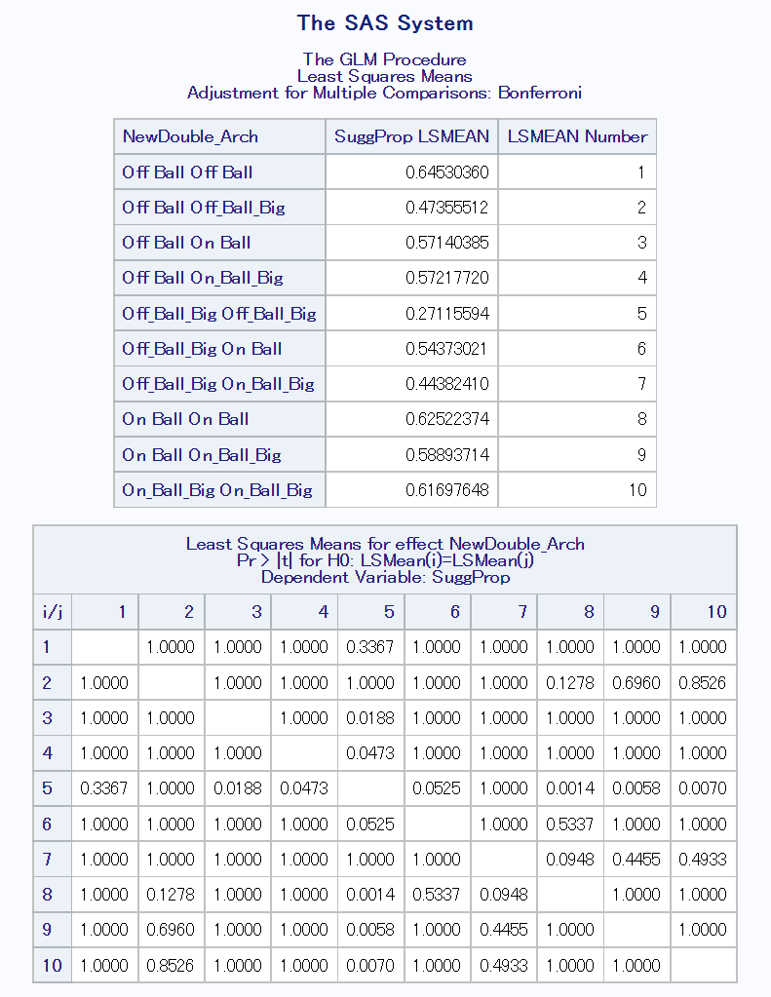

**Appendix B**

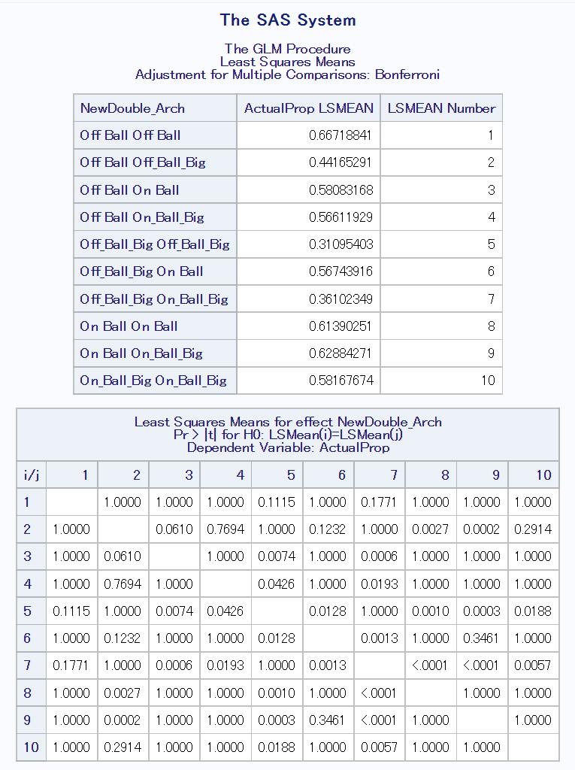

1. The lineup breakdowns on PBP stats did not include estimates of pace for each unit. The league average pace has hovered around 100 possessions/game in recent years [6]. This assumption allows Net Rating (Points/100 Possessions) to be used interchangeably with Points/48 Minutes.
2. This distribution of minutes is not perfectly optimized, as it does not maximize the point differential of the team due to the regularization term.
3. This analysis is only in the context of a team’s top two players. As such, many archetype combinations are less common or simply do not exist in this dataset (Two Roll and Cut Bigs).
4. Tables 2 and 3 list only a few of the significant *P*-values due to the high number of comparisons. As such, the Condensed Archetypes were used for ease of analysis.
5. Tables 4 and 5 list only a subset of the significant paired differences. The full results for each table can be seen in Appendix A and B respectively.